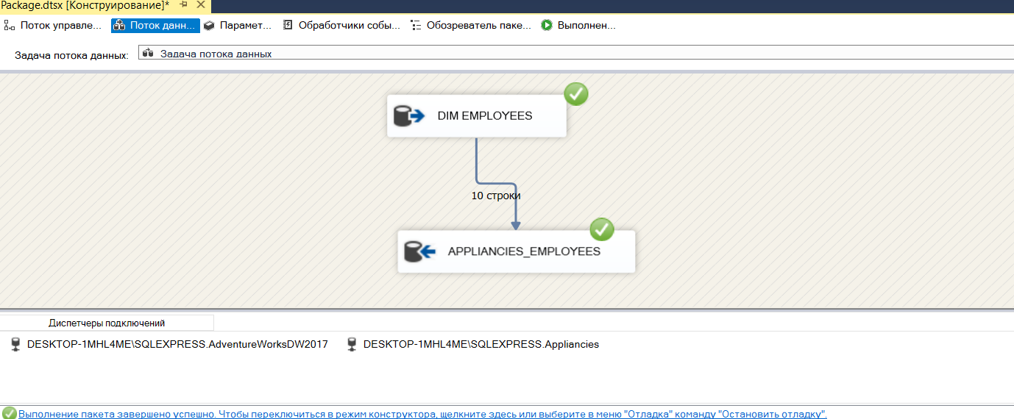

1. The AdventureWorksDW2017 database works faster with reports, because it is denormalized, which means that it has fewer tables, fewer Joins, so the database performance is better.